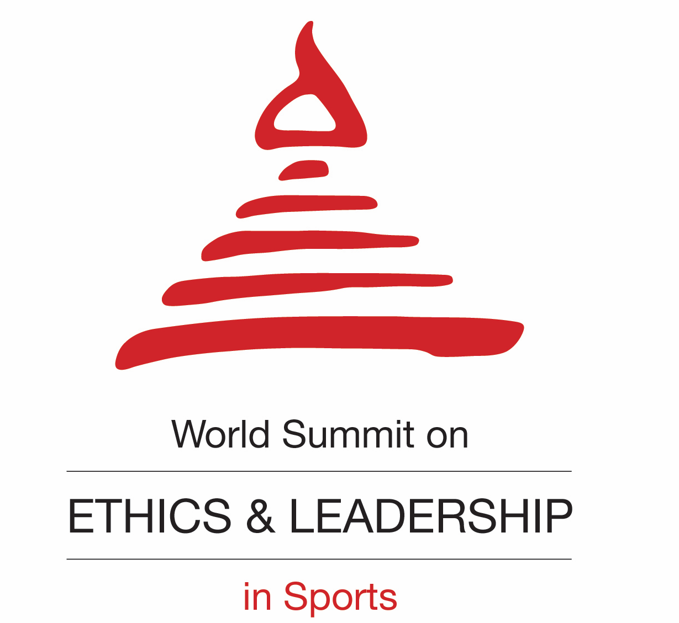

Accreditation Form
World Summit on Ethics and Leadership in Sports
16th September 2016, 08.30 am – 18.30 pm, FIFA Headquarters Zurich

I want to attend the Summit from____________o’clock till_____________o’clock
(please indicate the exact time)

with photographer/camera team

I want to attend the Summit and I am interested in an interview with
______________________________________ (please indicate speaker name).

Unfortunately I cannot attend but I would be pleased to receive press information
regarding the World Forum for Ethics in Business.

medium: _______________________________________________
desk: _______________________________________________
name: _______________________________________________
address: _______________________________________________
telephone: ____________________ telefax: ____________________
E-Mail: _______________________________________________
- Please provide a scan copy of your press ID -
*MEDIA CATEGORY (Please tick only one)
(I) Newspaper Electronic Newswire Magazine Radio
Online Medium/Blogger Freelancer

*MEDIA PROFILE (Please tick only one)
(II) Journalist Photographer TV Crew Blogger

*AUTHORISED BY

______________________ ___________________
Name of Editor/Chief of Bureau Signature with company stamp

Important Note:
Important Note:
Submission deadline for accreditation to the Summit: 12th September 2016
Please send your request for accreditation to press@wfeb.org with a scanned copy of your
valid press ID and the signed and stamped accreditation form.

WFEB Press Contact
Media Office
Tel: 0049 (0)151 43101428
press@wfeb.org
www.wfeb.org

